signInAuthenticationFailed1658929780368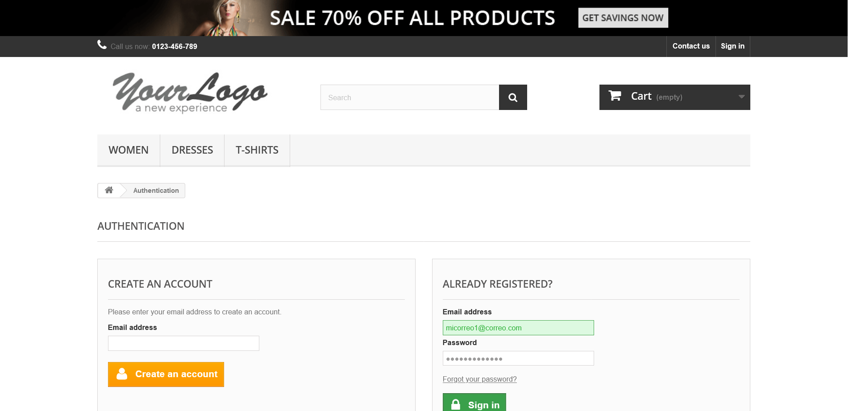

signInEmailInvalido1658929789661